*Florida International University*

*School of Computing and Information Sciences*

Software Engineering Focus

Feature Document

User Story ID #651

**Name:** Kyle Ryan

**Team Member(s):** Mario Fidalgo

**Project:** Mobile Judge 9.0

**Product Owner(s)**: Masoud Sadjadi

**Mentor(s)**: Masoud Sadjadi

**Instructor**: Masoud Sadjadi

**User Story Name: Add Checkbox to Filter Button in Students Tab**

* Description: As an admin, I would like to have the same filter functionality as in the Email Wizard so that I can select all, some, or none of the filters.

Acceptance Criteria

* I would like to be able to select any combination of Active, Dropped, or Inactive Students
* I would like to be able to select/unselect all of the students with the use of the checkbox.

**Use Case**

* Name: Add new checkbox to filter buttons in Students Tab
* Actor: Admin
* Preconditions: User must be logged in as an admin and in the people view then Judges tab.
* Description <Flow of events>:

1. User selects the checkbox to select/unselect all or the desired filter

2. System filters out the students who do not meet the filter criteria.

**Use Case Diagram**

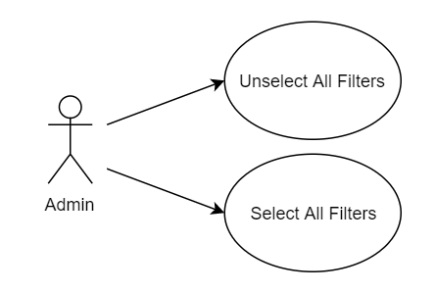

**Sequence Diagram**

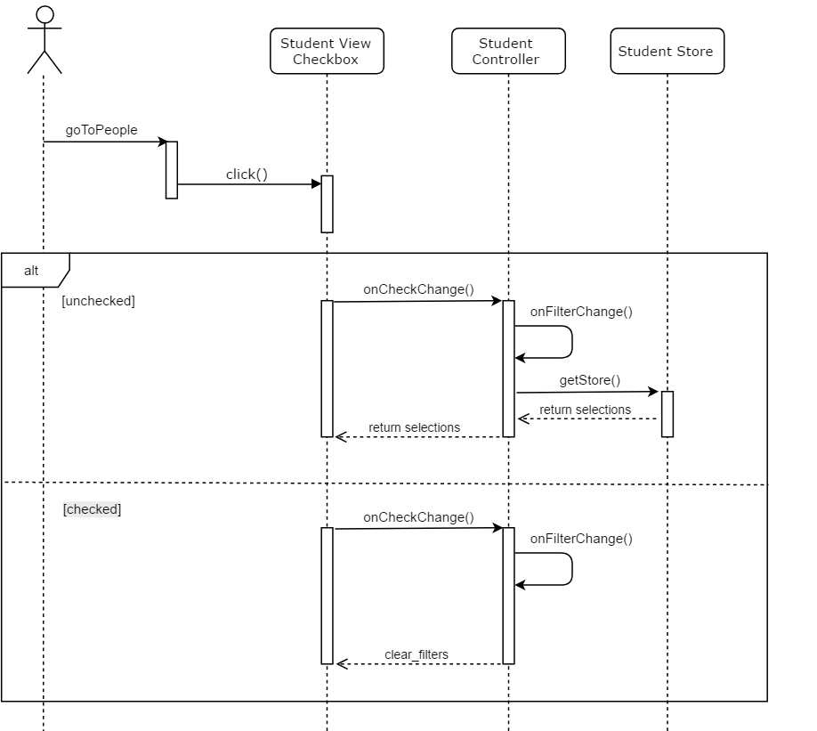

**Class Diagram**

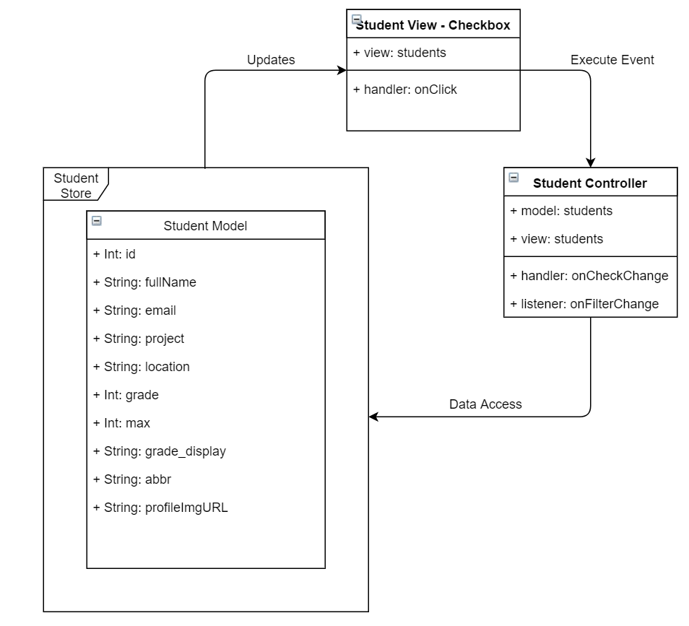

**Unit Test & Integration Test**

**Test case ID:** MJ-651-01

**Description/Summary of Test:** Select all the filter buttons in the Students Tab

**Precondition:** Admin is logged in and currently viewing the students tab found in people side tab.

**Expected Results:** When checkbox checked, all the filter buttons should become blue and selected, the view then shows the updated filter that has been applied.

**Actual Result:**When checkbox checked, all the filter buttons became blue and selected, the view then showed the updated filter that was applied.

**Status (Fail/Pass):** Pass

**Test case ID:** MJ-651-02

**Description/Summary of Test:** Unselect all the filter buttons in the Students Tab

**Precondition:** Admin is logged in and currently viewing the students tab found in people side tab.

**Expected Results:** When checkbox unchecked, all the filter buttons should become white and selected, the view then shows the updated filter that has been applied.

**Actual Result:**When checkbox unchecked, all the filter buttons became white and selected, the view then showed the updated filter that was applied.

**Status (Fail/Pass):** Pass

**Visual User Guide**

